KENT AMBASSADORS VISIT
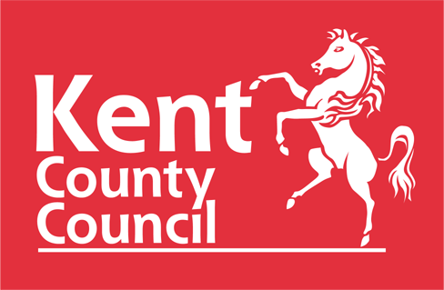
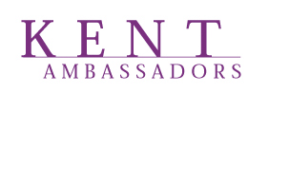

JASMIN VARDIMON AND KENT MUSIC VISIT
Creative Enterprise Quarter, Javelin Way, Ashford TN24 8FN

16 NOVEMBER 2023

5pm Arrival, drinks and nibbles in the JVH.O.M.E café.

5.30pm Welcome from Geoff Miles, Alison Tedbury (Executive Director Jasmin Vardimon Company) and Peter Bolton (Director Kent Music)

5.45pm Performance in Studio 2, as follows:-

Kent Music and Jasmin Vardimon Company will be working in partnership to offer local young people an opportunity to creatively collaborate across music and dance during October half term. Throughout four days of cross art form collaboration and experimentation young people from across Kent will develop a live performance piece of approximately 20 mins based around the theme of Underwater Worlds. Kent Music and Jasmin Vardimon Company will proudly present this creation developed with the young people to the Kent Ambassadors.

6.15pm Optional tour of the JVH.O.M.E and Kent Music buildings

Extra information please note

There is ample free parking around our and Kent Music’s building (opposite), and in the wider Creative Quarter.

Dress code: we would request that no one wears shoes which could potentially damage the Studio floors e.g., high heels.

The nearest station is Ashford International and is approx. 1 mile away

