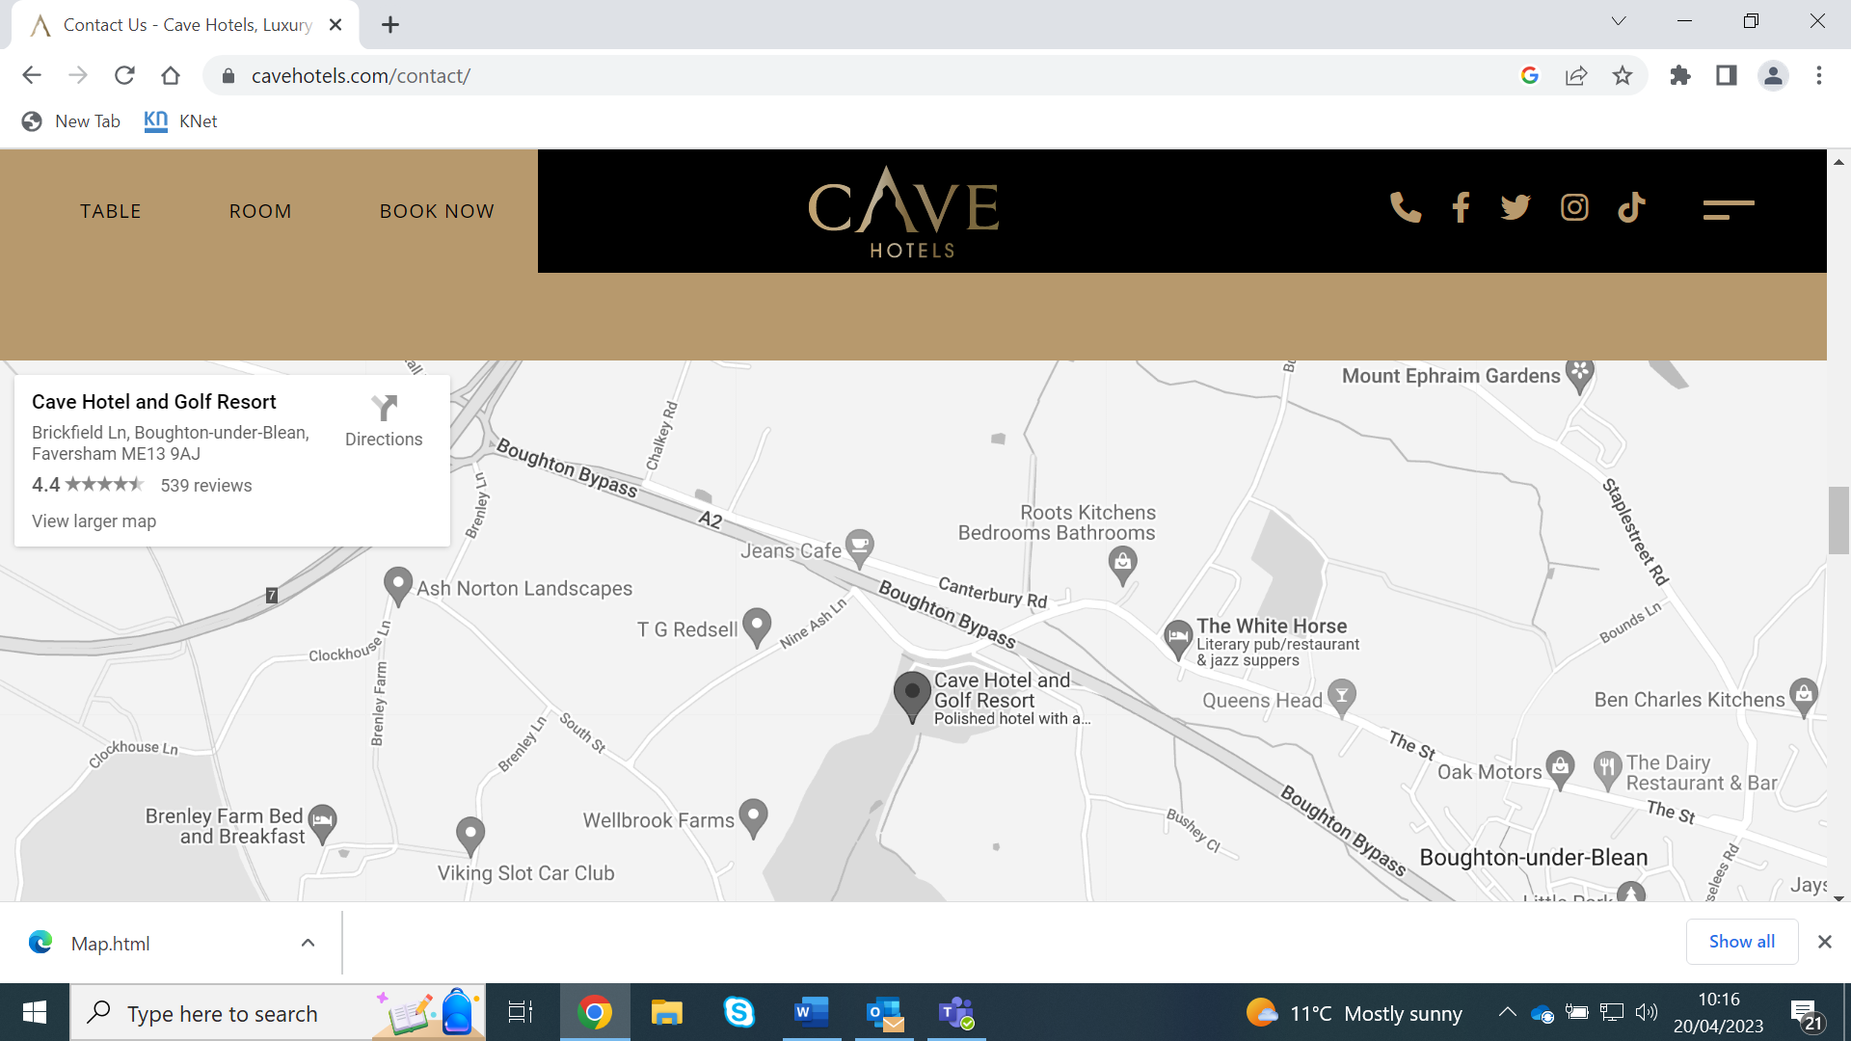

BY TRAIN – The Nearest station is Faversham which is 3.2 miles away from the hotel.

