KENT AMBASSADORS BRIEFING
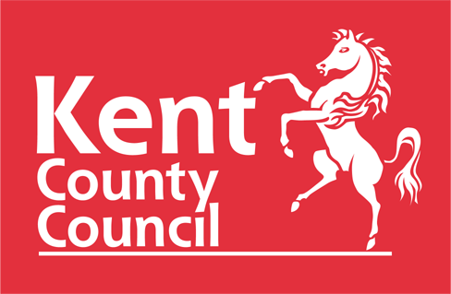
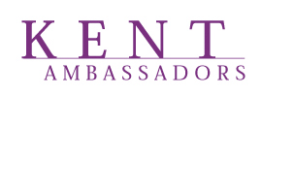

INCLUSIVITY AND DIVERSIFICATION BRIEFING

COMMISSIONERS HOUSE, CHATHAM HISTORIC DOCKYARD, ME4 4TZ

20 SEPTEMBER 2022

6.30pm Drinks reception

6.45pm Welcome by Richard Morsley, Chief Executive, Chatham Historic Dockyard

6.50pm Gurvinder Sandher, CEO, Kent Equality Cohesion Council

Setting the scene

7.05pm Hilary Cooke – Chair, Medway Pride CIC

LGBTQIA+ Beyond the Gender Binary

7.20pm Q&A for Gurvinder and Hilary

7.35pm Main Course

8.10pm Millie Knight, Paralympic Skier

A Kent girls’ Paralympic journey

8.25pm Michelle Bramble, Founder of North Kent Caribbean Network

Ticking the Boxes - Racial Equality and Me

8.40pm Q&A for Millie and Michelle

8.50pm Dessert
9.20pm Roger Gough, Leaders round up

9.35pm Q&A for Roger

9.50pm Closing remarks by Geoff Miles

10.00pm Event ends

