About RBLI

Royal British Legion Industries (RBLI) was formed in 1919 to support veterans returning from the Great War. Today RBLI is a national charity headquartered in a multigenerational village in Aylesford. The RBLI Village is home to more than 300 residents living in a mix of family homes, accessible independent apartments, supported living and care homes which specialise in Dementia Care. Officially launched by Her Majesty The Queen in 2019, RBLI’s Centenary Village is a £22m development creating more urgently needed accessible homes for veterans, and supported by a Kent Campaign Board chaired by Lord Colgrain DL.

Our national LifeWorks Programme, accredited by the MOD, operates from RBLI’s Capel Morris Centre in the village. The LifeWorks team delivers throughout the country and remotely via video link to military bases including Germany, Cyprus and Brunei.

As a national provider for the Department for Work and Pensions, RBL’s Work Programme supports people with disabilities in the workplace and works with their employers to ensure that they are providing accessible working opportunities to their staff.

Britain’s Bravest Manufacturing Co. (BBMC) where over 78% of employees are veterans or have a disability, and together they fulfil national tenders for companies including Network Rail, Barratt Developments and Highways England. BBMC’s Print and Mail site is located in Leatherhead, Surrey and its counterpart; Scotland’s Bravest Manufacturing Co. opened in 2019 is based in Renfrewshire near Glasgow.

Covid-19

Please do not attend site if you, or someone you have been in close contact with has tested positive or recently developed symptoms.

Prior to arriving on site, we ask that all guests complete our Covid-19 declaration. https://rbli.co.uk/covid-registration/ .

In order to visit RBLI’s care settings we must ask that all visitors provide proof of their Covid-19 vaccination status upon arrival and take a lateral flow test that morning.

To ensure the safety of our residents, we remain vigilant of the current Covid guidance. At this time, RBLI is asking all staff and visitors to wear masks in corridors and all residential accommodation. Closer to the tour date we will circulate the latest Covid-19 regulations being followed by RBLI.

Travel Information

Parking will be available in the Capel Morris Centre, best accessed from Hall Road. When driving to RBLI please use the Sat Nav postcode; ME20 7NL.

By Car
From Junction 5 on the M20, follow the A20 towards Aylesford and West Malling. Turn right at the roundabout into London Road, past the double set of traffic lights. At the next set of lights, with Sainsbury on your left, turn right into Hall Road.
The entrance to Royal British Legion Village is the second turning on the right off Hall Road. Upon entering the Village, take the first right turning into Capel Morris Centre car park.

By Train
The closest train stations are Aylesford, Barming and Maidstone East.
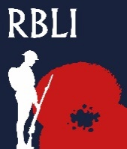
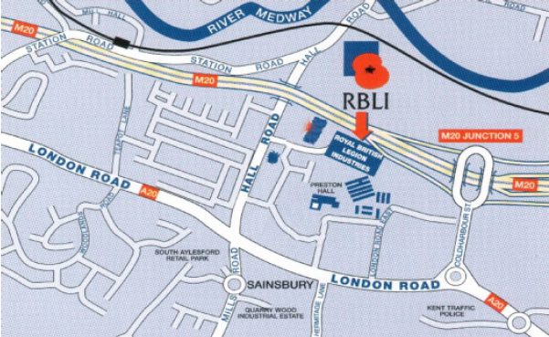
RBLI Head Office
Capel Morris Centre

Tour Schedule

1000 Arrival
All guests to park at The Capel Morris Centre – here you will be greeted by a member of the RBLI Team and shown into the centre.

Introduction and refreshments
An introduction to RBLI by Lisa Farmer, Chief Executive

Dependant on the number of attendees, at this point we may split the group and conduct smaller concurrent tours.

1020 Tour of Britain’s Bravest Manufacturing Co.
Introductions to the veterans who work at BBMC and an opportunity to see their work

1040 Tour of RBLI Village

Stop 1: Gavin Astor House and Appleton Lodge – RBLI’s care homes with specialist dementia facilities. Please note this may be external only dependent on the latest Covid guidance.

Stop 2: The Centenary Village – Please note that a maximum of 7 guests are allowed on the construction site at one time – the duration of this section will depend on the size of the group.

1200 Optional Lunch – Capel Morris Centre or Depart

