Economic Development
Invicta House
County Hall
Maidstone
Kent ME14 1XX
E-mail: allison.campbell-smith@kent.gov.uk

Direct dial/Ext: | 03000 417040
Ask For: | Allison Campbell-Smith
Your Ref:
Our Ref:
Date: | January 20

Dear Kent Ambassadors

Kent Ambassadors– Kent County Council Briefing

I am now 3 months into my role as Leader and would like to take this opportunity to introduce you to my cabinet and tell you in more detail about my plans for the council in the future.

To this end I would like to invite you to County Hall on the 26th March for dinner and a briefing.

The dress code for the evening will be lounge suits.

Please see the attached agenda for the timings and let Allison know by e-mail at allison.campbell-smith@kent.gov.uk by return if you can attend or not so that the relevant arrangements can be made.

I hope to see you in March

Yours sincerely
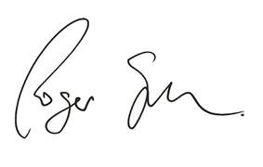
Roger Gough
Leader, Kent County Council

