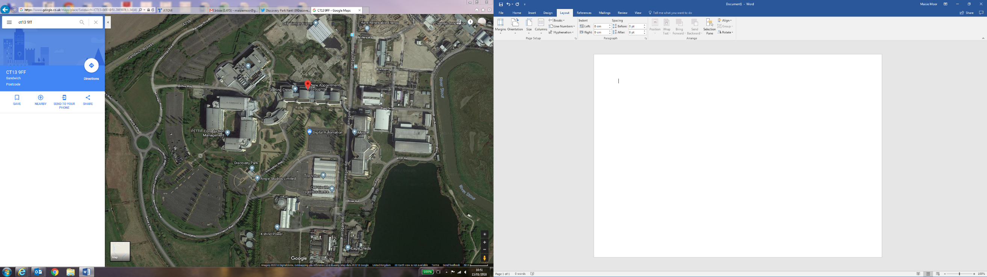

Disabled Visitor Parking

The Gateway

Visitor Parking

Visitor Parking