Regeneration and Economy
Invicta House
County Hall
Maidstone
Kent ME14 1XX
Fax: (01622) 221636
E-mail: allison.campbell-smith@kent.gov.uk

Direct dial/Ext: | 01622 221364
Ask For: | Allison Campbell-Smith
Your Ref:
Our Ref:
Date: | April 12

Kent Ambassadors Away Days

I am pleased to invite you to join me on the Ambassador annual away days. The topic this year will be Green Technology.

Following our successful visits in previous years we have decided to be based at the Tudor Marriott in Bearsted again this year. We hope this will again give you the opportunity to network and spend some quality time with your fellow Ambassadors.

Our visit will start at 8.00am at the Tudor Marriott on 10th July and finish at approximately 2.00pm the following day. As you will see from the attached draft agenda following last years successful volunteering day we will be following this format again. For those staying at the hotel we will all meet there in the morning and then drive independently to the different volunteering projects throughout the County. If you are not staying over you can make your own way straight to the volunteering venue. Please indicate your first and second choice of venue that you would like to visit on the attached fax back form.

The Ambassador programme will meet the costs associated with accommodation and meals. Please be aware that there will be some walking involved at the site visits, some of it on uneven and muddy ground. Walking boots or wellingtons may be advisable for this part of the day, these can be left on the bus when not needed.

I do hope you will be able to join me and have attached a fax back form for you to indicate your availability. Please let Allison have your availability by 4 May 2012

Yours sincerely
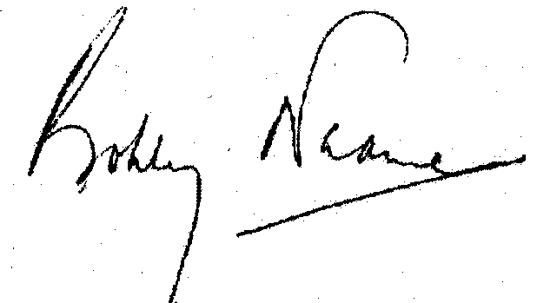
Bobby Neame
Chairman, Kent Ambassadors

