HOW TO FIND US

ellenor Gravesend
Coldharbour Road
Gravesend
Kent
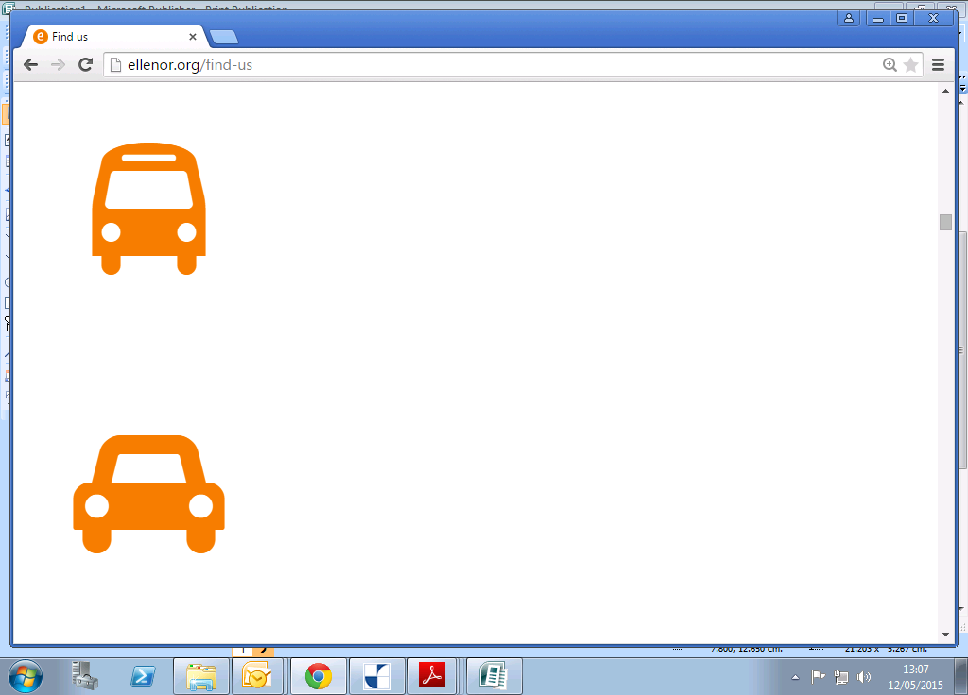
DA11 7H

BY CAR

BY public transport

From M25 – exit at Junction 2, Darenth Interchange; join A2 towards Canterbury/Dover.
From A2 – exit at Gravesend Central junction.
Take the first exit at both the first and second roundabouts. At the Morrisons Superstore roundabout, go straight ahead and our entrance is on the first right.
From coast/Canterbury take M2/A2 towards London.
From A2 – exit at A227 Gravesend Central.
Take third exit at first roundabout, first exit (straight over) at second roundabout, and then first exit at third roundabout. At the Morrisons Superstore roundabout, go straight ahead and our entrance is on the first right.
N.B. - We recommend you use the Morrisons free car park and cross over to ellenor on foot, via the exit in the wall parallel to the road.
Nearest bus route is 499 – stop ‘Northfleet Oaklands Road’ on Coldharbour Road.
From Ebbsfleet International Station, take a 499 bus towards Riverview Park Leisure Centre takes approximately 15 minutes.
From Northfleet Station, take the fastrack ‘B’ to Ebbsfleet International Station, then change to the 499 bus towards Riverview Park Leisure Centre.
From Gravesend Station, take the 499 towards Bluewater.
N.B. Fastrack ‘B’ only comes as close as the ‘Perry Street Vale Road’ stop. From here commuters will need to alight and walk to Perry Street All Saints Church to pick up the 499 bus.

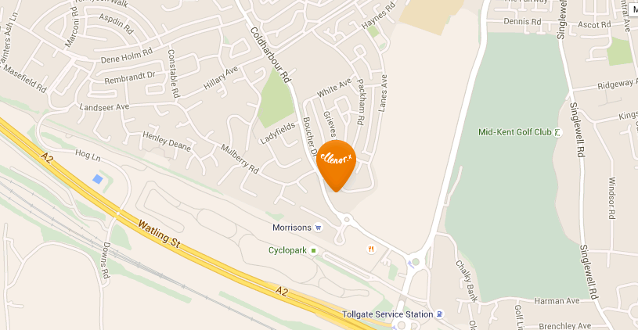
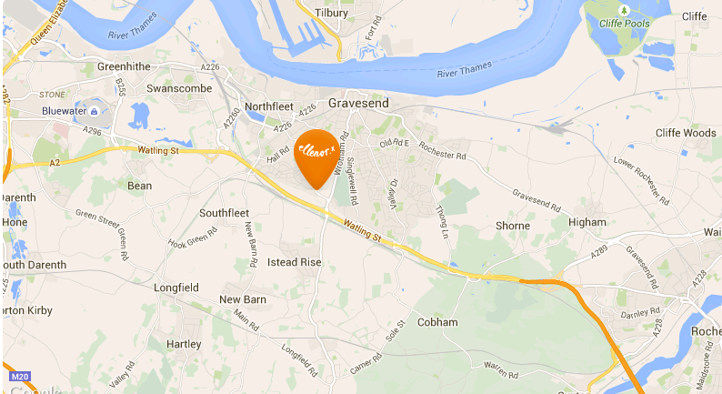

MAP OF GRAVESEND

DETAILED MAP

