KENT AMBASSADORS BRIEFING

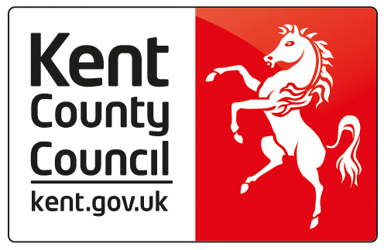

STROKE ASSOCIATION

Turkey Mill
29 Hollingworth Close
Maidstone
Kent
ME14 5PP

9TH FEBRUARY 2017

10.30 Arrival for tea and coffee

Welcome by Becky Beard, Community and Events Fundraising Manager - South East

2 or 3 presentations by stroke survivors.

Question and Answer session.

Break into 4 groups for blood pressure checks for those that want to participate.

12.30 Depart

