KENT AMBASSADORS BRIEFING
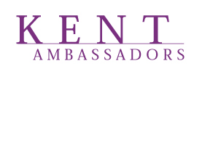
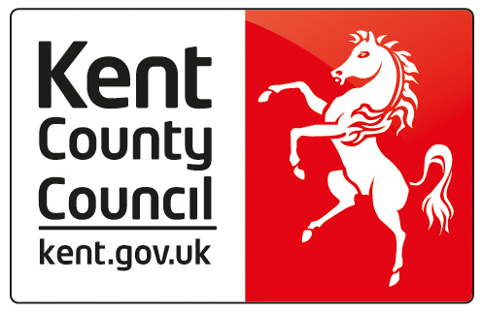

THE MOUNT VINEYARD, THE MOUNT, CHURCH STREET, SHOREHAM, SEVENOAKS, KENT, TN14 7SD

20TH ANNIVERSARY AND PRODUCED IN KENT

4TH DECEMBER 2018

7.00 – 7.30 Arrival and Drinks Reception

7.30 – 7.35 Introduction and Opening Remarks by Richard Collins, Chairman, Kent Ambassadors

7.35 – 7.45 Alex King, The History of the Ambassadors

7.45 – 7.55 Paul Carter to toast Ambassadors and Richard to respond

7.55 – 8.00 Richard and Alex to cut the cake and photo opportunity

8.00 – 9.00 Dinner (Bowl food)

9.00 – 9.10 PiNK Speaker

9.10 – 9.30 Dessert

9.30 Closing Remarks by Richard Collins

