KENT AMBASSADORS BRIEFING
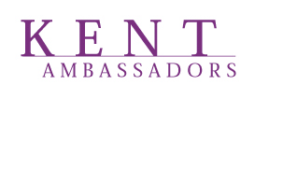


DARENT ROOM, COUNTY HALL, MAIDSTONE

PROMOTING KENT WORKSHOP

4TH OCTOBER 2018

1000-1030 Arrival and coffee

1030 – 1040 Welcome and introduction from the Chairmen of Locate in Kent and Visit Kent
David Fitzsimmons and Jonathan Neame

1040-1050 The future of work A thought-provoking insight into future trend spotting
Gavin Cleary

1050-1055 The opportunity to align the agendas of Visit Kent and Locate in Kent and work more closely
Gavin Cleary and Deirdre Wells

1055-1105 Key challenges and opportunities and top line ambitions for the coming 5 years
Gavin Cleary and Deirdre Wells

1105-1120 Questions and comments

1120-1140 Inspiration Shots – 3 live case studies amplifying the case for Kent as a great choice for business location, tourism growth, drivers and dependencies for future success

1140-1200 Feedback to panel, questions and comments from the floor

1200 Finish

