
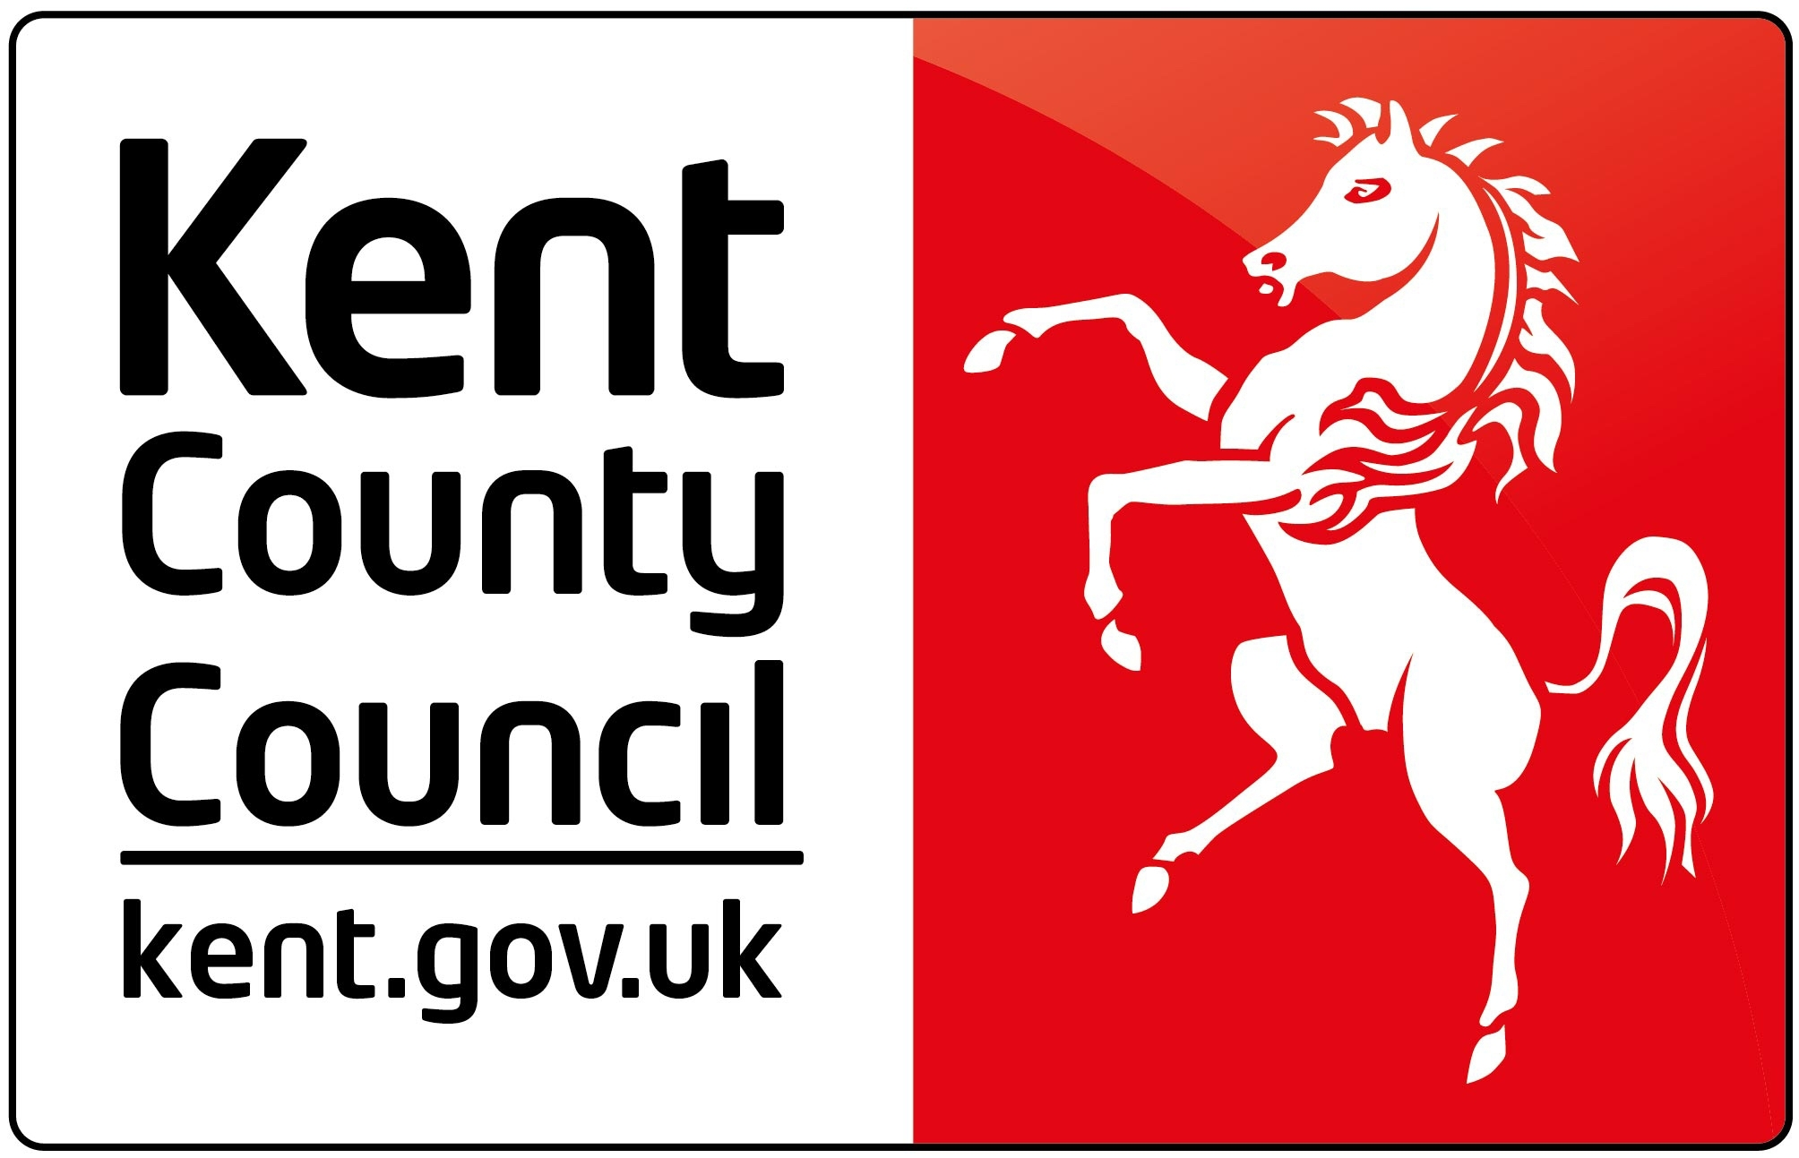

AMBASSADORS BRIEFING, 6 DECEMBER 2012

HERITAGE AND HISTORY

DOVER CASTLE

AGENDA

5.00 – 6.30 Optional Tour of Operation Dynamo – Rescue from Dunkirk and / or the Castle

6.30 – 7.00 Drinks Reception and Networking in the NAAFI building

7.00 – 7.05 Welcome by Richard Collins,
Chairman of Ambassadors

7.05 – 7.35 Starter and discussion

7.35 – 7.50 Sandra Matthews-Marsh, Visit Kent

Heritages Importance to the Kent Economy

7.50 – 8.35 Main Course and discussion

8.35 – 8.50 Paul Hudson, Chairman, Heritage Lottery Fund

"HLF - have you noticed us in Kent?"

8.50 – 9.05 Dr Andy Brown, Planning & Conservation Director, South East
English Heritage

Presenting, protecting, promoting: 3 sides of English Heritage

9.05 – 9.30 Dessert and discussion

9.30 – 9.45 Alex King, Deputy Leader, Kent County Council

End of Year Round Up

9.45 – 10.00 Questions and Answers

10.00 Close by Richard Collins

