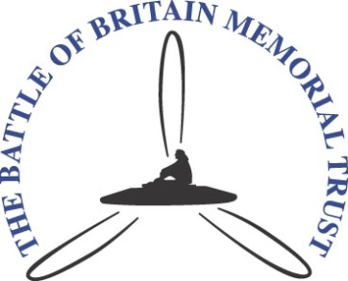

VISIT BY AMBASSADORS TO THE BATLE OF BRITAIN MEMORIAL
TUESDAY 6 OCTOBER 2015

1000 Arrival and Coffee in Geoffrey Page Centre

1015 Welcome and brief by Patrick Tootal

1030 Guided tour of the Memorial Site
(brollies and coats may be needed!)

1130 Visit the Scramble Experience

1200 Visit Cockpit Cafe

1230 Light refreshments

