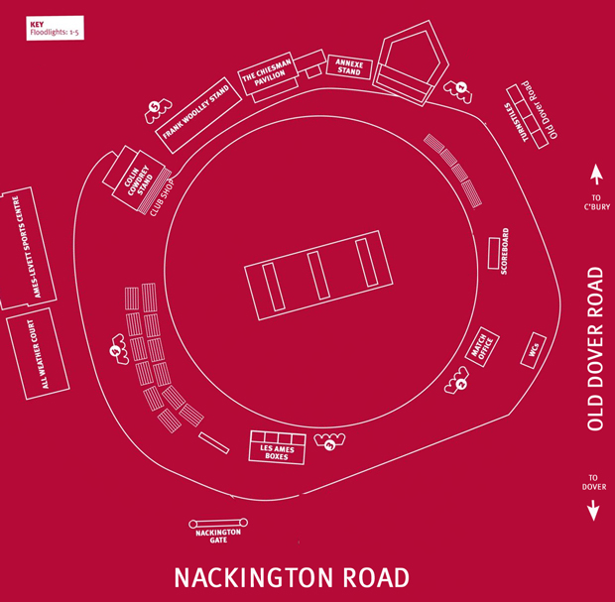
Spitfire Ground St Lawrence – Kent County Cricket

