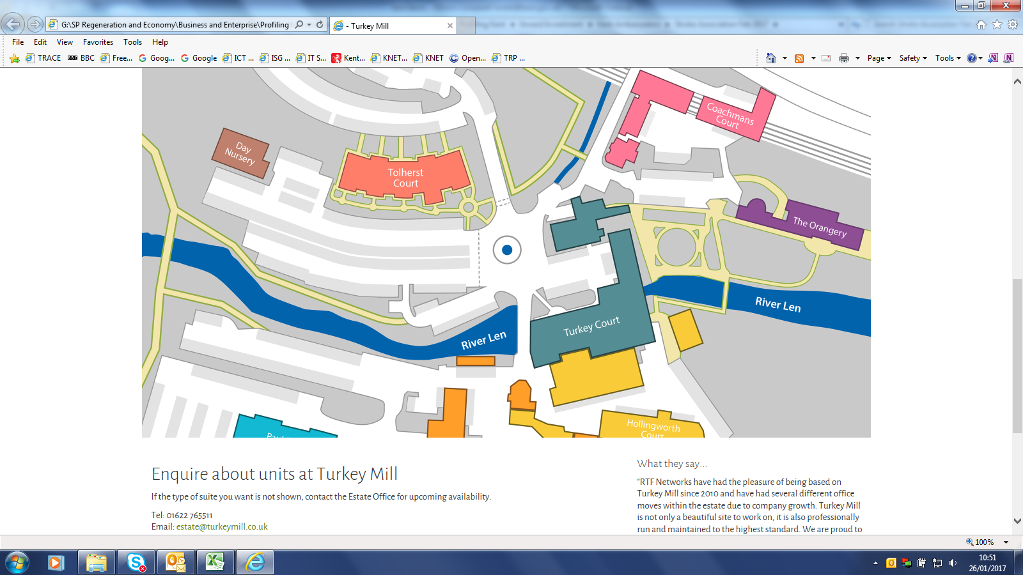
Please park in the main visitor car park.
Walk over the bridge next to Turkey Court.
Bear left opposite Hollingworth Court and the Stroke Association Office is on the left hand side.

