Map & Directions to Rochester Cathedral

Rochester Cathedral is located in the heart of Rochester's busy high street and a five minute walk from Rochester train station.
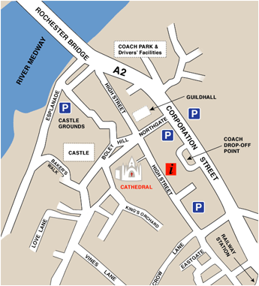
If you are travelling by road you may wish to use the AA Route Planner. Rochester Cathedral's postcode is ME1 1SX.

