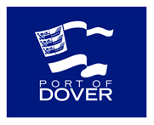

Kent Ambassadors Visit
18th June 2015

10.00 | Visitors to arrive at Cruise Terminal 1
10.05 | Welcome from Tim Waggott, Chief Executive
10.15 | Viewing of the Port of Dover film
10.30 | Dover Western Docks Revival Vision – presentation
11.00 | Tour of the Port  - Terminal Control  - DWDR Marketing Suite
12.30 | Networking Lunch
13.30 | Departure

