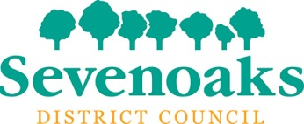

Dear All
I am delighted to invite you to a briefing at Sevenoaks District Council on the morning of the 22nd August.
The briefing will start at 10.00am at the Council Offices on Argyle Road, Sevenoaks, TN13 1HG.
There is a small amount of on-site parking but I would recommend parking in one of the local pay and display carparks shown on the attached map as the offices do get busy.
The event will end at 12.30pm with an optional buffet lunch.
Amongst other things you will hear about the key features of the Sevenoaks District which is a diverse mixture of towns and rural villages. They will outline their innovative approach to running a District Council which includes their achievements in becoming self-sufficient and non-reliant on Government grants. They will explain how their innovative approach to property investments has led to them to winning a number of prestigious awards.
It promises to be a really interesting morning finding out about a unique way to run a local council.
Please come back to me by return with your availability and if you are able to attend please let me know if you will be staying for lunch.
Kind regards

Allison Campbell-Smith
Programme Manager, Kent Ambassadors
03000 417040

