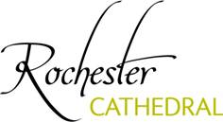

Dear Kent Ambassadors,

I am delighted to extend a warm welcome to the Cathedral on 10th November 2016.

Despite the various challenges of our Project “Hidden Treasures, Fresh Expression” we are now nearing completion and the official opening will be on 1st November. I will be able to take you around both the Library and Crypt which has greatly enhanced the visitor experience and provided a fantastic space for small concerts, seminars, meetings and other events. We are enormously grateful to all of our Funders and supporters who have stuck with us through some very difficult times. What has been achieved, I hope you will agree, is quite stunning.

The visit will start with coffee/tea at 11.15am followed by a tour starting at 11.30am. After the tour, a light lunch of sandwiches will be served in the Cathedral Tea Rooms.

Please respond directly to Allison by return to let her have your availability. She has attached a map for your information and please be aware we are limited to a maximum number of 20 so places will be allocated on a first come first served basis.

I hope to meet you on 10th.

Regards
Yours sincerely
Dr Philip Hesketh
Dean, Rochester Cathedral

