The site is approached from either Dover or Folkestone on the B2011 at Capel le Ferne. Here are two maps to help.

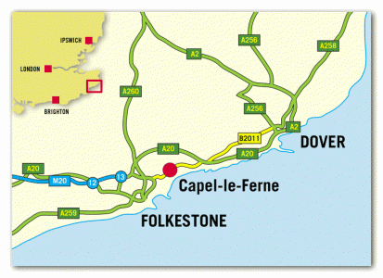

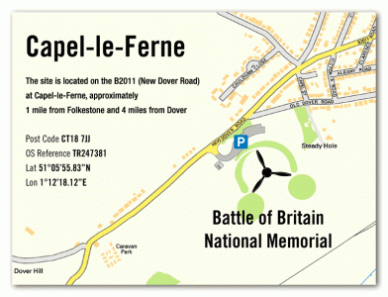

FOR SAT NAV PLEASE USE CT18 7JJ

