Old Johnson House, Burley Road, Sittingbourne, Kent, ME10 1JX

Directions from the M2 coming from Canterbury
At junction 5 take the A249 exit to Sittingbourne/Maidstone/Sheerness/M20/M25
At the roundabout, take the 3rd exit onto Maidstone Road/A249
Take the A2 exit towards Rainham/Sittingbourne
At the roundabout, take the 4th exit onto Key Street/A2 and continue to follow A2
Turn right onto Burley Road
Take the next right turning, continue to the end of the road and Porchlight’s parking will be on your right
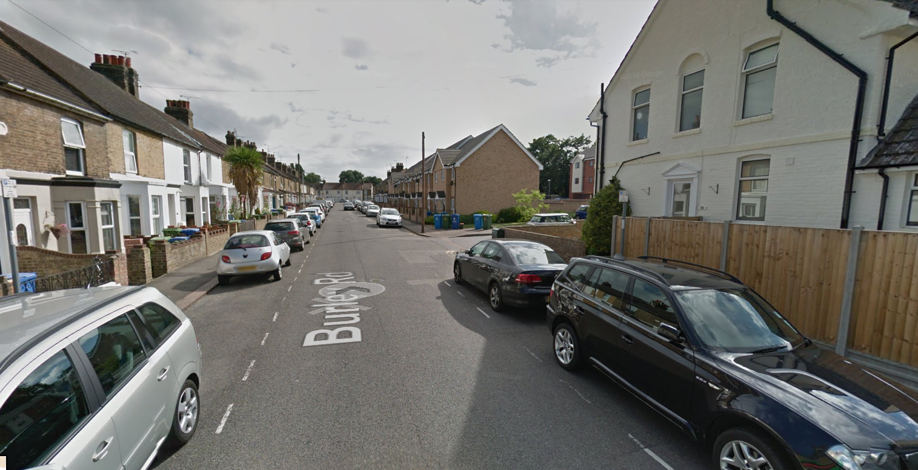

Directions from the train station
Head West towards the roundabout and continue onto Dover Street/A2
Slight left to stay on Dover Street
At the Lidl store turn right onto West Street
Turn left onto Burley Road and follow directions as above to Old Johnson House

Please note, if you use Sat Nav, it will direct you to Burley Road, but not to the entrance of Old Johnson House

